Birla Institute of Technology & Science, Pilani
Work-Integrated Learning Programmes Division
Second Semester 2024-2025
Mid-Semester Test (EC-3 Regular)

Course No. : CSZG525/CSIZG525/ESZG526/SSZG525
Course Title : Advanced Computer Networks
Nature of Exam : Open Book
No. of Pages = 2

No. of Questions = 7
Weightage : 40%
Duration : 2 Hrs
Date of Exam : 23/05/2025

Note:
- Please follow all the Instructions to Candidates given on the cover page of the answer book.
- All parts of a question should be answered consecutively. Each answer should start from a fresh page.
- Assumptions made if any, should be stated clearly at the beginning of your answer.

- With reference to IEEE 802.11, describe the Distributed Coordination Function (DCF) and how it ensures fair access among nodes. Explain the significance of inter-frame spacing (SIFS, DIFS) and back-off timers in avoiding collisions. [5 Marks]

- Compare the performance of traditional TCP and Split TCP in the provided network graph under a route break between nodes E and F. Explain how traditional TCP would react to packet loss versus how Split TCP allows local recovery between C and F. Analyze the improvement in delay and throughput and the potential impact on fairness with other flows. [5 Marks]

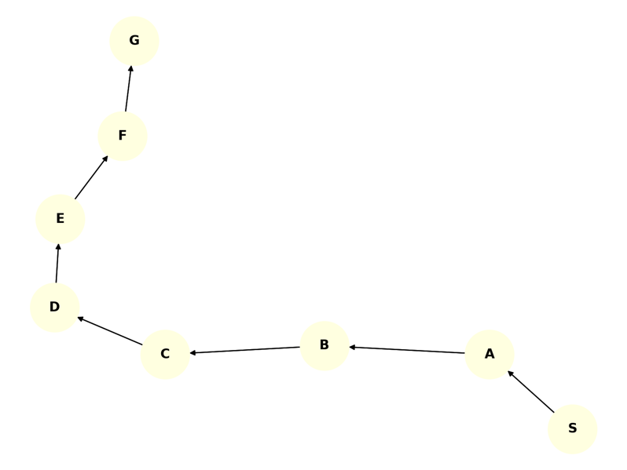

- Explain how SDN enables intelligent network management through the separation of control and data planes. Discuss the role of the SDN controller in enforcing network-wide policies, providing examples of how it communicates with both applications and network devices. Analyze how this architectural shift from traditional networks improves scalability, flexibility, and fault tolerance in modern enterprise and cloud environments. [6 Marks]

- Describe the need for Content Delivery Networks (CDNs) in the context of modern content-heavy applications such as video streaming, cloud gaming, and large-scale web services. Explain how server placement philosophies—namely “Enter Deep” and “Bring Home”—affect content delivery performance. Additionally, evaluate how cluster selection strategies like IP Anycast and DNS redirection optimize user experience and network efficiency in real-time content delivery. [6 Marks]

- Analyze the hidden terminal problem in wireless networks and explain why CSMA/CD fails to work effectively in such environments. Describe how the RTS/CTS mechanism mitigates this issue and improves channel access reliability in IEEE 802.11-based systems. [6 Marks]

- Referencing the network topology shown, describe how AODV discovers a route from node A to node G on-demand. Explain the role of RREQ (Route Request), RREP (Route Reply), and RERR (Route Error) messages. Discuss how sequence numbers and hop count help ensure loop-free and up-to-date routing paths. [6 Marks]

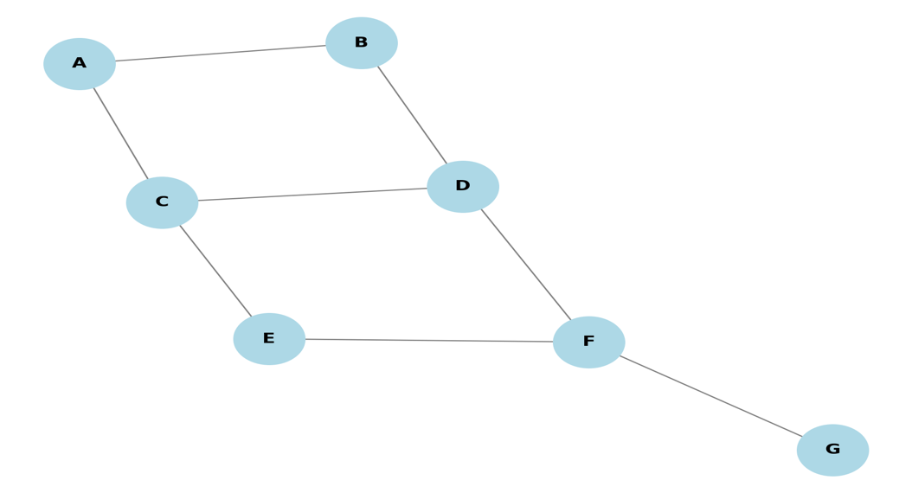

- Refer to the directed wireless ad-hoc network graph where node S wishes to communicate with node G. Explain why traditional TCP may misinterpret packet loss along the route as congestion. Describe how TCP-F (TCP Feedback) enhances end-to-end communication in such a dynamic network by using ACK+ROUTE messages. Illustrate how intermediate nodes help the sender distinguish between congestion and route failure, and analyze how TCP-F improves throughput and reduces recovery time in this topology. [6 Marks]
